ELEMENTS OF COMPUTING SYSTEMS-II

A Project Report
Submitted by
Group – 12

MITHIN CB.EN.U4AIE22132
CHARAN CB.EN.U4AIE22119
VIKASH CB.EN.U4AIE22156
CHARISH CB.EN.U4AIE22142

in partial fulfillment for the award of the degree of

BACHELOR OF TECHNOLOGY
IN
CSE(AI)



Centre for Computational Engineering and Networking
AMRITA SCHOOL OF ARTIFICIAL INTELLIGENCE

AMRITA VISHWA VIDYAPEETHAM
COIMBATORE - 641 112 (INDIA)
JULY - 2023

AMRITA SCHOOL OF ARTIFICIAL INTELLIGENCE
AMRITA VISHWA VIDYAPEETHAM
COIMBATORE - 641 112



BONAFIDE CERTIFICATE

This is to certify that the report entitled “ELEMENTS OF COMPUTING SYSTEMS-II” submitted by MITHIN (CB.EN.U4AIE22132), CHARAN (CB.EN.U4AIE22119), VIKASH (CB.EN.U4AIE22156), CHARISH (CB.EN.U4AIE22142), for the award of the Degree of Bachelor of Technology in the “CSE(AI) ” is a bonafide record of the work carried out by her under our guidance and supervision at Amrita School of Artificial Intelligence, Coimbatore.

Ms. Sreelakshmi K
Project Guide

Dr. K.P.Soman
Professor and Head CEN

Submitted for the university examination held on 13-07-2023.

DECLARATION

We, MITHIN (CB.EN.U4AIE22132), CHARAN (CB.EN.U4AIE22119), VIKASH (CB.EN.U4AIE22156), CHARISH (CB.EN.U4AIE22142) hereby declare that this report entitled “ELEMENTS OF COMPUTING SYSTEMS-II”, is the record of the original work done by me under the guidance of Ms. Sreelakshmi K, Assistant Professor, Centre for Computational Engineering and Networking, Amrita School of Artificial Intelligence, Coimbatore. To the best of my knowledge this work has not formed the basis for the award of any degree/diploma/ associate ship/fellowship/or a similar award to any candidate in any University.

MITHIN CB.EN.U4AIE22132

CHARAN CB.EN.U4AIE22119

VIKASH CB.EN.U4AIE22156

CHARISH CB.EN.U4AIE22142

Place: Coimbatore
Date: 02-07-2023

Contents
ACKNOWLEDGEMENT 6
List Of Figures 7
ABSTRACT 8
1. PART A 10
1.1. INTRODUCTION: 10
1.1.1. MEMORY (DATA & INSTRUCTION MEMORY): 11
1.1.2. HACK CPU: 11
1.1.3. EXTERNAL INPUT & OUTPUT(I/O): 14
1.2. METHODOLOGY: 15
1.2.1. HDL Code for CPU: 16
1.2.2. HDL Code for Memory: 17
1.2.3. HDL Code for Hack Computer: 18
1.3. EXPERIMENTS & RESULTS: 18
1.3.1. MEMORY: 18
1.3.2. CPU: 23
1.3.3. COMPUTER Add: 27
1.3.4. COMPUTER Add-external: 28
1.3.5. COMPUTER Max: 30
1.3.6. COMPUTER Max-external: 31
1.3.7. COMPUTER Rect: 33
1.3.8. COMPUTER Rect-external: 34
1.3.9. COMPUTER Even-Odd (Newly created): 35
1.4. CONCLUSION: 36
2. PART B 37
2.1 INTRODUCTION: 37
2.2 METHODOLOGY: 38
2.3 EXPERIMENTS & RESULTS: 42
2.4 CONCLUSION: 42
3. PART C 43
3.1 MORSE CODE ENCRYPTION & DECRYPTION: 43
3.1.1 INTRODUCTION: 43
3.1.2 METHODOLOGY: 44
3.1.3 EXPERIMENTS & RESULTS: 54
3.2 ENCRYPTION & DECRYPTION USING CAESER CIPHER: 55
3.2.1 INTRODUCTION: 55
3.2.2 METHODOLOGY: 56
3.2.3 EXPERIMENTS & RESULTS: 64
3.3 CONCLUSION: 65
REFERENCES 66

ACKNOWLEDGEMENT

The successful completion of this project would not have been possible without the support and guidance of several individuals and organizations. We express our sincere gratitude to AMRITA VISHWA VIDYAPEETHAM, who provided us with the resources and facilities necessary to carry out this project.

We would also like to extend our appreciation to our advisor, Ms. Sreelakshmi mam, Assistant professor who provided invaluable guidance and support throughout the project.

Additionally, we would like to acknowledge the efforts of our project team members, who worked tirelessly to bring this project to fruition. Their hard work and dedication were critical to our success.

Finally, we would like to thank all the stakeholders who provided support in various ways. Your contributions have been instrumental in making this project a reality.

We are truly grateful for all the support received, and we hope that this project will serve as a testament to the positive impact of collaboration and teamwork.

List Of Figures

Figure 1 Hack computer structure 11

Figure 2 Hack CPU structure 14

Figure 3 Hack computer 15

Figure 4 Memory output test 19

Figure 5 CPU output test 24

Figure 6 Computer Add output test 28

Figure 7 Computer Add-external output test 29

Figure 8 Computer Max output test 31

Figure 9 Computer Max-external output test 32

Figure 10 Computer Rect output test 34

Figure 11 Computer Rect-external output test 35

Figure 12 Computer Even-odd output test 36

Figure 13 Symbol table output 43

Figure 14 Morse code encryption output 55

Figure 15 Morse code decryption output 55

Figure 16 Caeser cipher encryption output 65

Figure 17 Caeser cipher decryption output 65

ABSTRACT

This project consists of three parts,
- Implementing the HACK computer in HDL and testing it:
This project focuses on implementing and testing a Hack computer using HDL. The Hack computer, an educational architecture, is designed in a modular and hierarchical manner, connecting the CPU, memory, I/O devices, and control logic. Thorough testing is conducted using the simulators in nand2tetris to validate the functionality and performance of the implemented Hack computer. This project showcases the capabilities of HDL in computer system design and verification, ensuring the reliability and accuracy of the Hack computer implementation.

- Implementing a symbol table using jack program:
This project focuses on implementing a symbol table using the Jack programming language. The symbol table serves as a critical data structure for organizing and retrieving information about identifiers in a program. It involves designing the necessary components, algorithms, and operations to efficiently manage symbols, including variables, methods, and classes. Thorough testing is conducted to ensure the correctness and effectiveness of the symbol table implementation, covering various scenarios and edge cases. This project showcases the significance of a well-implemented symbol table in supporting the compilation process and demonstrates its role in facilitating accurate symbol resolution and management within a program written in the Jack programming language.

- Implementing encryption and decryption methods in jack program:
- Encryption and decryption of Morse code:
This project involves the development of a Jack program capable of encrypting and decrypting Morse code. The program utilizes data structures and algorithms to convert between plain text and Morse code representations, allowing for secure message transmission. Thorough testing ensures the accuracy and efficiency of the encryption and decryption processes, showcasing the practical application of the Jack programming language in Morse code cryptography.

- Encryption and decryption using Caeser cipher:
This project aims to develop a user-friendly Jack program for implementing the Caesar cipher encryption and decryption algorithm. The program includes modules for input processing, encryption, and decryption, allowing users to securely encrypt messages by shifting each letter a specified number of positions down the alphabet, and decrypt them by reversing the shift. Thorough testing ensures the program's accuracy, robustness, and ability to handle various characters, providing a practical application of the Jack programming language in message encryption and decryption using the Caesar cipher.

PART A

INTRODUCTION:

This report focuses on implementing the Hack computer architecture using Hardware Description Language (HDL). The Hack computer is an educational platform that provides a simplified understanding of computer systems and low-level programming. By implementing it in HDL, this project aims to gain practical experience in digital design and explore the inner workings of a functional computer system.

The Hack architecture includes the CPU, memory, I/O devices, and control logic, interconnected to execute instructions and store data. HDL allows us to model and simulate these components, providing a scalable and manageable implementation process.

This report provides detailed insights into the design, challenges faced, and testing methodologies used. The project aims to deepen our understanding of computer architecture, digital design principles, and the role of HDL in developing complex systems.
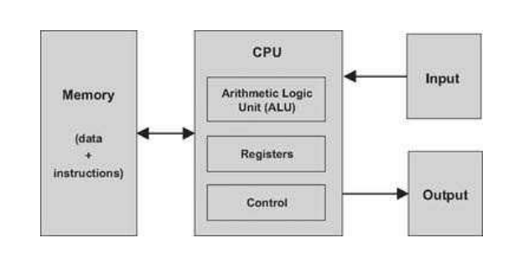
Figure 1 Hack computer structure

MEMORY (DATA & INSTRUCTION MEMORY):
      - DATA MEMORY:
Variables, arrays, and objects are examples of abstract artifacts that high-level programs can manipulate. These data abstractions are converted into a series of binary integers in machine language, which are then saved in the computer's data memory. It is possible to read or write t single word after choosing it from the data memory by giving its address. We obtain the word's value in the first scenario.I n the latter scenario, we erase the previous value and save a new one in the chosen location.
      - INSTRUCTION MEMORY:
Each high-level command is converted into a set of binary words that correspond to the commands in machine language. The instruction memory of the computer is where these instructions are kept. The CPU retrieves (or reads) a word from the instruction memory at each stage of the computer's operation, decodes it, execute the word's designated instruction, and then determines which instruction to execute next. As a result, altering the information in the instruction memory has a significant impact on how the computer functions. [1]

The instructions that are stored in the instruction memory are written in machine language, which is a common formalisation. Depending on the machine, each operation's specification and the codes for its operands may be contained in a single-word instruction. This specification was divided by other computers into many words.

HACK CPU:
The central processor unit (CPU) of the Hack computer is an internalized integrated logic unit. It is in charge of carrying out the commands from the loaded programme. These commands instruct the CPU to perform a number of calculations, read and write values out of and into memory, and conditionally jump to other commands in the programme. Three key pieces of hardware—an Arithmetic-Logic Unit (ALU), a set of registers, and a control unit—help the CPU carry out these operations.
      - Arithmetic Logic Unit (ALU): The ALU is designed to carry out all of the computer's basic arithmetic and logical operations. A standard ALU can do operations like adding two integers, determining whether a number is positive, changing the bits in a word of data, and more.
      - Registers: The CPU is made to perform speedy computations for simple problems. The results of these calculations should be stored locally rather than being sent in and out of memory in order to improve performance.
As a result, each CPU has a tiny number of fast registers, each of which can store a single word.
      - Control Unit: A binary code typically 16, 32, or 64 bits wide is used to represent a computer instruction.Such an instruction must first be decoded in order to use the information it contains to advise the ALU, registers, and memory on how to carry out the command. Some control unit is in charge of decoding the instructions and determining which instruction to fetch and execute next.
      - Registers: Registers are small, high-speed storage units within a computer's central processing unit (CPU) or processor. They are used to store and manipulate data during the execution of instructions. Registers are typically implemented as small groups of flip-flops, which are basic building blocks of digital circuits capable of storing binary information.
      - Data registers: The CPU can access short-term memory through these registers. For instance, in order to compute and remember the value of (a - b), we must first compute the value of (a - b). This result can be locally saved inside the CPU—in a data register—instead of being temporarily stored in some memory address.
      - Addressing registers: In order to read and write data, the CPU must constantly access the memory. Each of these actions requires us to provide an address in order to designate which specific memory word needs to be accessed. This address can be found in the present instruction in certain circumstances, but in others, it depends on the execution of an earlier instruction. In the latter scenario, the address ought to be saved in an addressing register, a register whose contents can be later used to represent a memory address.
      - Program counter register: When running a program, the CPU must always keep track of the address of the subsequent instruction that needs to be retrieved from the instruction memory. This information is stored in the program counter register. This address is saved in a unique register known as the PC, or program counter. The address for retrieving instructions from the instruction memory is then calculated based on the contents of the PC. The CPU, therefore, updates the PC in one of two ways while carrying out the current command. The PC is incremented to point to the following instruction in the program if the present instruction lacks a goto directive. The CPU loads n into the PC if the current instruction contains a goto n directive that needs to be performed.
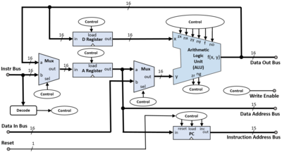
Figure 2 Hack CPU structure

EXTERNAL INPUT & OUTPUT(I/O):
Computers use a wide variety of input and output (I/O) devices to communicate with their surrounding environments. In addition to the bewildering variety of proprietary components that embedded computers are required to handle in vehicles, weapon systems, medical equipment, and other devices, these include screens, keyboards, printers, scanners, network interface cards, CD-ROMs, and so on. We won't be discussing the anatomy of these different gadgets here for two reasons. First of all, each one of them is a special machine that calls for specialised engineering skills. Second, and for the same reason, computer scientists have developed a number of strategies to make any single item appear identical to a computer. Memory-mapped I/O, the simplest method in this field, is referred to.
    - HACK COMPUTER:
In the Hack hardware hierarchy, the top chip is a full-fledged computer system that can run programmes written in the Hack machine language. All of the hardware components required to run a computer, including a CPU, a data memory, an instruction memory (ROM), a screen, and a keyboard, are implemented as internal pieces on the computer chip. The program's code must be preloaded into the ROM before it can be executed. According to the Screen and Keyboard chip requirements, the control of the screen and keyboard is accomplished through the use of their respective memory maps. [2]
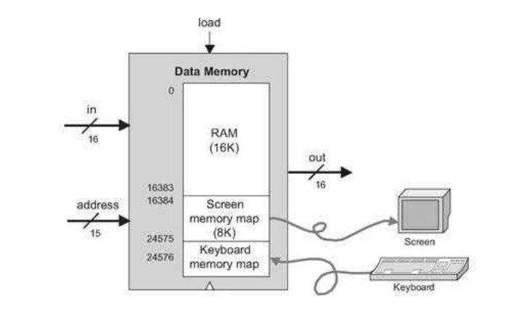
Figure 3 Hack computer

METHODOLOGY:

Implementing the HACK computer in HDL (Hardware Description Language) involves several steps. The HACK computer is a simple computer architecture designed as part of the Nand to Tetris course. Here's an outline of the procedures involved:
- Familiarize Yourself with the HACK Architecture: Understand the overall architecture of the HACK computer, including its CPU, memory, input/output, and instruction set architecture. Review the relevant documentation and materials available from the Nand to Tetris course.
- Write HDL Code for the Control Unit: Begin by implementing the control unit, which is responsible for generating control signals based on the current instruction being executed. Write HDL code to define the behavior of the control unit and its outputs.
- Write HDL Code for the ALU: Implement the Arithmetic Logic Unit (ALU), which performs arithmetic and logical operations. Write HDL code for the ALU's behavior, including the necessary arithmetic and logical operations specified in the project.
- Write HDL Code for the Registers: Implement the registers required by the HACK computer, including the program counter (PC), A register, D register, and temporary registers. Write HDL code for each register and define their behavior and functionality.
- Integrate the Components: Connect the control unit, ALU, and registers together to form the complete CPU. Define the necessary inputs, outputs, and internal signals to facilitate communication between the components. Ensure that the signals are connected correctly.

- Implement Memory: Design and implement the memory modules of the HACK computer, including the program memory (ROM) and data memory (RAM). Write HDL code for these modules and integrate them with the CPU.
- Implement Input/Output: Define the input/output interface of the HACK computer. This typically involves implementing modules for keyboard input, screen output, and other peripherals as required by your design goals.
- Testing: Develop a test bench to verify the functionality of your HDL implementation. Create test cases that cover various aspects of the HACK architecture, including instruction execution, memory access, and input/output operations, or since the test scripts for testing memory and CPU are already present in the Project05 of Nand to Tetris you can use them for testing.
- Simulate and Debug: Use an HDL simulator to simulate the behavior of your HACK computer design. Run the test bench and analyze the simulation results. Debug any issues or errors that arise and make the necessary modifications to your HDL code.

HDL Code for CPU:

CHIP CPU {

IN inM[16], // M value input (M = contents of RAM[A])
instruction[16], // Instruction for execution
reset; // Signals whether to re-start the current
// program (reset==1) or continue executing
// the current program (reset==0).

OUT outM[16], // M value output
writeM, // Write to M?
addressM[15], // Address in data memory (of M)
pc[15]; // address of next instruction

PARTS:
// Put your code here:
Not(in=instruction[15], out=Ainstruction);
Not(in=Ainstruction, out=Cinstruction);
And(a=Cinstruction, b=instruction[5], out=ALUtoA);
Mux16(a=instruction, b=ALUout, sel=ALUtoA, out=Aregin);
Or(a=Ainstruction, b=ALUtoA, out=loadA);
ARegister(in=Aregin, load=loadA, out=Aout);
Mux16(a=Aout, b=inM, sel=instruction[12], out=AMout);
And(a=Cinstruction, b=instruction[4], out=loadD);
DRegister(in=ALUout, load=loadD, out=Dout);
ALU(x=Dout, y=AMout, zx=instruction[11], nx=instruction[10],
zy=instruction[9], ny=instruction[8], f=instruction[7],
no=instruction[6], out=ALUout, zr=ZRout, ng=NGout);
// Set outputs for writing memory
Or16(a=false, b=Aout, out[0..14]=addressM);
Or16(a=false, b=ALUout, out=outM);
And(a=Cinstruction, b=instruction[3], out=writeM);
// calc PCload & PCinc - whether to load PC with A reg
And(a=ZRout, b=instruction[1], out=jeq);
And(a=NGout, b=instruction[2], out=jlt);
Or(a=ZRout, b=NGout, out=zeroOrNeg);
Not(in=zeroOrNeg, out=positive);
And(a=positive, b=instruction[0], out=jgt);
Or(a=jeq, b=jlt, out=jle);
Or(a=jle, b=jgt, out=jumpToA);
And(a=Cinstruction, b=jumpToA, out=PCload);
Not(in=PCload, out=PCinc);
PC(in=Aout, inc=PCinc, load=PCload, reset=reset, out[0..14]=pc);
}

HDL Code for Memory:

CHIP Memory {
IN in[16], load, address[15];
OUT out[16];
PARTS:
// Put your code here:
// choose where to send load bit
DMux(in=load, sel=address[14], a=loadram, b=loadscreenkbd);
DMux(in=loadscreenkbd, sel=address[13], a=loadscreen, b=blank); // scrn or kbd
// load into RAM and screen
RAM16K(in=in, load=loadram, address=address[0..13], out=outram);
Screen(in=in, load=loadscreen, address=address[0..12], out=outscreen);
// only care about reading for keyboard
Keyboard(out=outkbd);
// choose the right output
Mux4Way16(a=outram, b=outram, c=outscreen, d=outkbd, sel=address[13..14], out=out);
}

HDL Code for Hack Computer:

CHIP Computer {
IN reset;
PARTS:
// Put your code here:
ROM32K(address=pc, out=instruction);
CPU(inM=memOut, instruction=instruction, reset=reset, outM=outM,
writeM=writeM, addressM=addressM, pc=pc);
Memory(in=outM, load=writeM, address=addressM, out=memOut);
}

EXPERIMENTS & RESULTS:

The output produced, after the testing and debugging process is done,

MEMORY:
      - Output test:

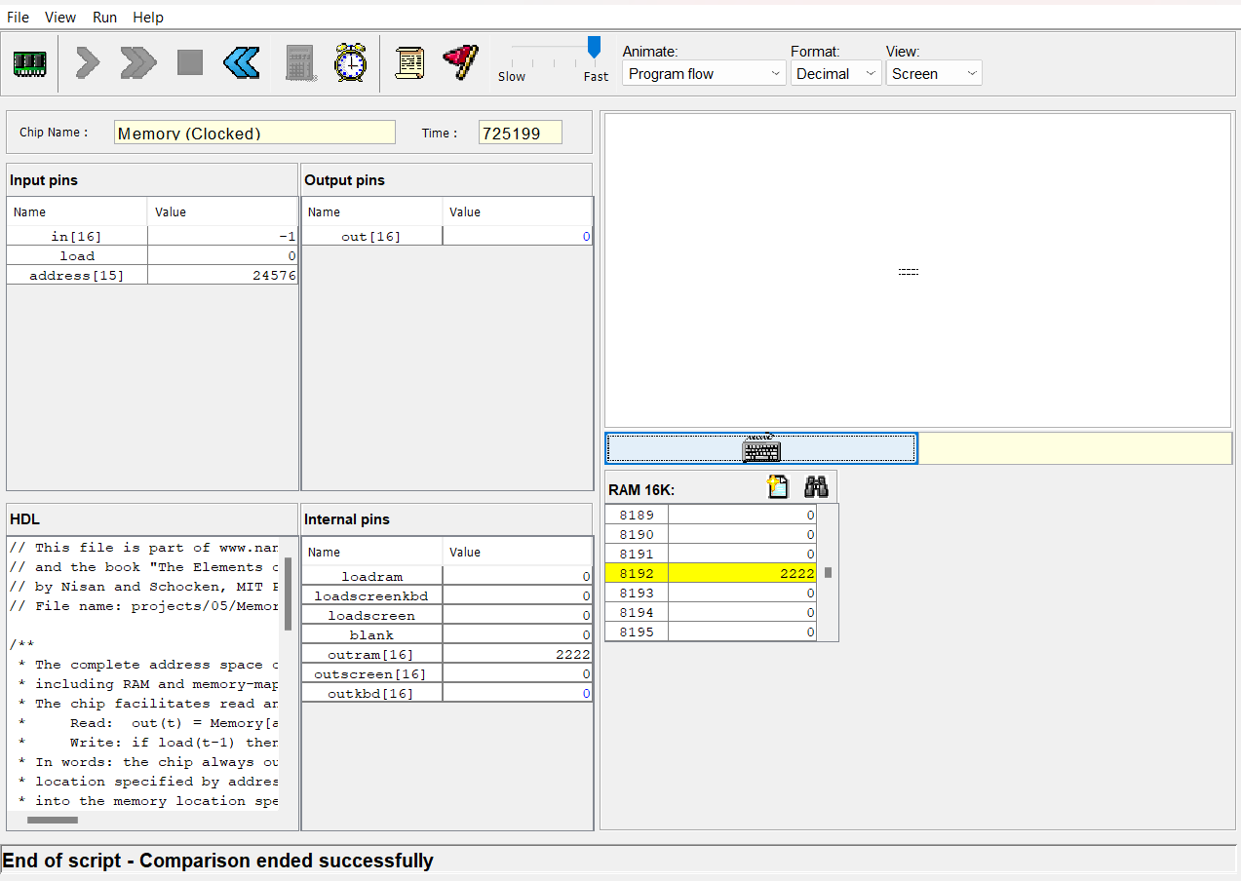

Figure 4 Memory output test

      - Test script:

// This file is part of www.nand2tetris.org
// and the book "The Elements of Computing Systems"
// by Nisan and Schocken, MIT Press.
// File name: projects/05/Memory.tst

load Memory.hdl,
output-file Memory.out,
compare-to Memory.cmp,
output-list in%D1.6.1 load%B2.1.2 address%B1.15.1 out%D1.6.1;
echo "Before you run this script, select the 'Screen' option from the 'View' menu";

// There is an interesting design error that has shown up in several students'
// Memory.hdl files that causes zeros to be written in the corresponding offset
// in the inactive memory segments to the actual write. To detect this, the
// test must not only look for writes into the wrong segment, but changes.
// The following initialization writes a signal number into the memory where
// the bad writes may occur.
//// Set RAM[2000], RAM[4000] = 12345 (for following overwrite test)
set in 12345, set load 1, set address %X2000, tick, output; tock, output;
set address %X4000, tick, output; tock, output;

set in -1, // Set RAM[0] = -1
set load 1,
set address 0,
tick,
output;
tock,
output;

set in 9999, // RAM[0] holds value
set load 0,
tick,
output;
tock,
output;

set address %X2000, // Did not also write to upper RAM or Screen
eval,
output;
set address %X4000,
eval,
output;

//// Set RAM[0], RAM[4000] = 12345 (for following overwrite test)
set in 12345, set load 1, set address %X0000, tick, output; tock, output;
set address %X4000, tick, output; tock, output;

set in 2222, // Set RAM[2000] = 2222
set load 1,
set address %X2000,
tick,
output;
tock,
output;

set in 9999, // RAM[2000] holds value
set load 0,
tick,
output;
tock,
output;

set address 0, // Did not also write to lower RAM or Screen
eval,
output;
set address %X4000,
eval,
output;

set load 0, // Low order address bits connected
set address %X0001, eval, output;
set address %X0002, eval, output;
set address %X0004, eval, output;
set address %X0008, eval, output;
set address %X0010, eval, output;
set address %X0020, eval, output;
set address %X0040, eval, output;
set address %X0080, eval, output;
set address %X0100, eval, output;
set address %X0200, eval, output;
set address %X0400, eval, output;
set address %X0800, eval, output;
set address %X1000, eval, output;
set address %X2000, eval, output;

set address %X1234, // RAM[1234] = 1234
set in 1234,
set load 1,
tick,
output;
tock,
output;

set load 0,
set address %X2234, // Did not also write to upper RAM or Screen
eval, output;
set address %X6234,
eval, output;

set address %X2345, // RAM[2345] = 2345
set in 2345,
set load 1,
tick,
output;
tock,
output;

set load 0,
set address %X0345, // Did not also write to lower RAM or Screen
eval, output;
set address %X4345,
eval, output;

//// Clear the overwrite detection value from the screen
set in 0, set load 1, set address %X4000, tick, output; tock, output;

// Keyboard test

set address 24576,
echo "Click the Keyboard icon and hold down the 'K' key (uppercase) until you see the next message (it should appear shortly after that) ...",
// It's important to keep holding the key down since if the system is busy,
// the memory will zero itself before being outputted.

while out <> 75 {
tick, tock, // tick, tock prevents hang if sync. parts used in KB path.
}

clear-echo,
output;

// Screen test

//// Set RAM[0FCF], RAM[2FCF] = 12345 (for following overwrite test)
set in 12345, set load 1, set address %X0FCF, tick, output; tock, output;
set address %X2FCF, tick, output; tock, output;

set load 1,
set in -1,
set address %X4FCF,
tick,
tock,
output,

set address %X504F,
tick,
tock,
output;

set address %X0FCF, // Did not also write to lower or upper RAM
eval,
output;
set address %X2FCF,
eval,
output;

set load 0, // Low order address bits connected
set address %X4FCE, eval, output;
set address %X4FCD, eval, output;
set address %X4FCB, eval, output;
set address %X4FC7, eval, output;
set address %X4FDF, eval, output;
set address %X4FEF, eval, output;
set address %X4F8F, eval, output;
set address %X4F4F, eval, output;
set address %X4ECF, eval, output;
set address %X4DCF, eval, output;
set address %X4BCF, eval, output;
set address %X47CF, eval, output;
set address %X5FCF, eval, output;

set load 0,
set address 24576,
echo "Make sure you see ONLY two horizontal lines in the middle of the screen. Hold down 'Y' (uppercase) until you see the next message ...",
// It's important to keep holding the key down since if the system is busy,
// the memory will zero itself before being outputted.

while out <> 89 {
tick, tock, // tick, tock prevents hang if sync. parts used in KB path.
}
clear-echo,
output

CPU:
      - Output test:

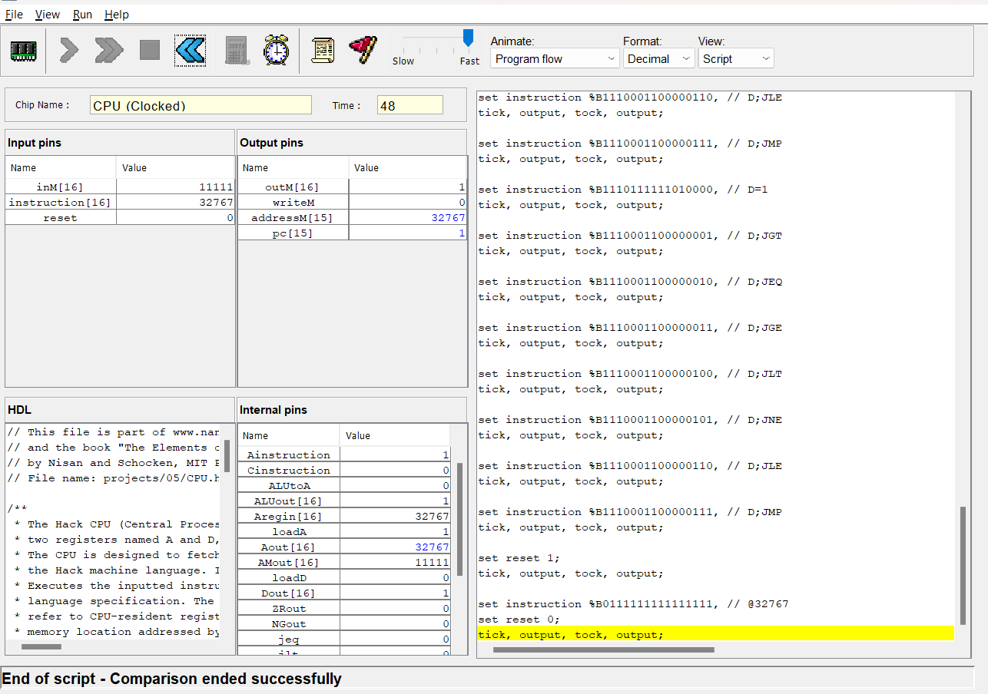
Figure 5 CPU output test

      - Test script:

// This file is part of www.nand2tetris.org
// and the book "The Elements of Computing Systems"
// by Nisan and Schocken, MIT Press.
// File name: projects/05/CPU.tst

load CPU.hdl,
output-file CPU.out,
compare-to CPU.cmp,
output-list time%S0.4.0 inM%D0.6.0 instruction%B0.16.0 reset%B2.1.2 outM%D1.6.0 writeM%B3.1.3 addressM%D0.5.0 pc%D0.5.0 DRegister[]%D1.6.1;

set instruction %B0011000000111001, // @12345
tick, output, tock, output;

set instruction %B1110110000010000, // D=A
tick, output, tock, output;
set instruction %B0101101110100000, // @23456
tick, output, tock, output;

set instruction %B1110000111110000, // AD=A-D
tick, output, tock, output;

set instruction %B0000001111101011, // @1003
tick, output, tock, output;

set instruction %B1110001100001000, // M=D
tick, output, tock, output;

set instruction %B0000001111101100, // @1004
tick, output, tock, output;

set instruction %B1110001110011000, // MD=D-1
tick, output, tock, output;

set instruction %B0000001111101000, // @1000
tick, output, tock, output;

set instruction %B1111010011110000, // AD=D-M
set inM 11111,
tick, output, tock, output;

set instruction %B0000000000001110, // @14
tick, output, tock, output;

set instruction %B1110001100000100, // D;jlt
tick, output, tock, output;

set instruction %B0000001111100111, // @999
tick, output, tock, output;

set instruction %B1111110111100000, // A=M+1
tick, output, tock, output;

set instruction %B1110001100101000, // AM=D
tick, output, tock, output;

set instruction %B0000000000010101, // @21
tick, output, tock, output;

set instruction %B1110011111000010, // D+1;jeq
tick, output, tock, output;

set instruction %B0000000000000010, // @2
tick, output, tock, output;

set instruction %B1110000010111000, // AMD=D+A
tick, output, tock, output;

set instruction %B1111110111001000, // M=M+1
tick, output, tock, output;

set instruction %B1111110010101000, // AM=M-1
tick, output, tock, output;

set instruction %B0000001111101000, // @1000
tick, output, tock, output;

set instruction %B1110111010010000, // D=-1
tick, output, tock, output;

set instruction %B1110001100000001, // D;JGT
tick, output, tock, output;

set instruction %B1110001100000010, // D;JEQ
tick, output, tock, output;

set instruction %B1110001100000011, // D;JGE
tick, output, tock, output;

set instruction %B1110001100000100, // D;JLT
tick, output, tock, output;

set instruction %B1110001100000101, // D;JNE
tick, output, tock, output;

set instruction %B1110001100000110, // D;JLE
tick, output, tock, output;

set instruction %B1110001100000111, // D;JMP
tick, output, tock, output;

set instruction %B1110101010010000, // D=0
tick, output, tock, output;

set instruction %B1110001100000001, // D;JGT
tick, output, tock, output;

set instruction %B1110001100000010, // D;JEQ
tick, output, tock, output;

set instruction %B1110001100000011, // D;JGE
tick, output, tock, output;

set instruction %B1110001100000100, // D;JLT
tick, output, tock, output;

set instruction %B1110001100000101, // D;JNE
tick, output, tock, output;

set instruction %B1110001100000110, // D;JLE
tick, output, tock, output;

set instruction %B1110001100000111, // D;JMP
tick, output, tock, output;

set instruction %B1110111111010000, // D=1
tick, output, tock, output;

set instruction %B1110001100000001, // D;JGT
tick, output, tock, output;

set instruction %B1110001100000010, // D;JEQ
tick, output, tock, output;

set instruction %B1110001100000011, // D;JGE
tick, output, tock, output;

set instruction %B1110001100000100, // D;JLT
tick, output, tock, output;

set instruction %B1110001100000101, // D;JNE
tick, output, tock, output;

set instruction %B1110001100000110, // D;JLE
tick, output, tock, output;

set instruction %B1110001100000111, // D;JMP
tick, output, tock, output;

set reset 1;
tick, output, tock, output;

set instruction %B0111111111111111, // @32767
set reset 0;
tick, output, tock, output;

COMPUTER Add:
      - Output test:

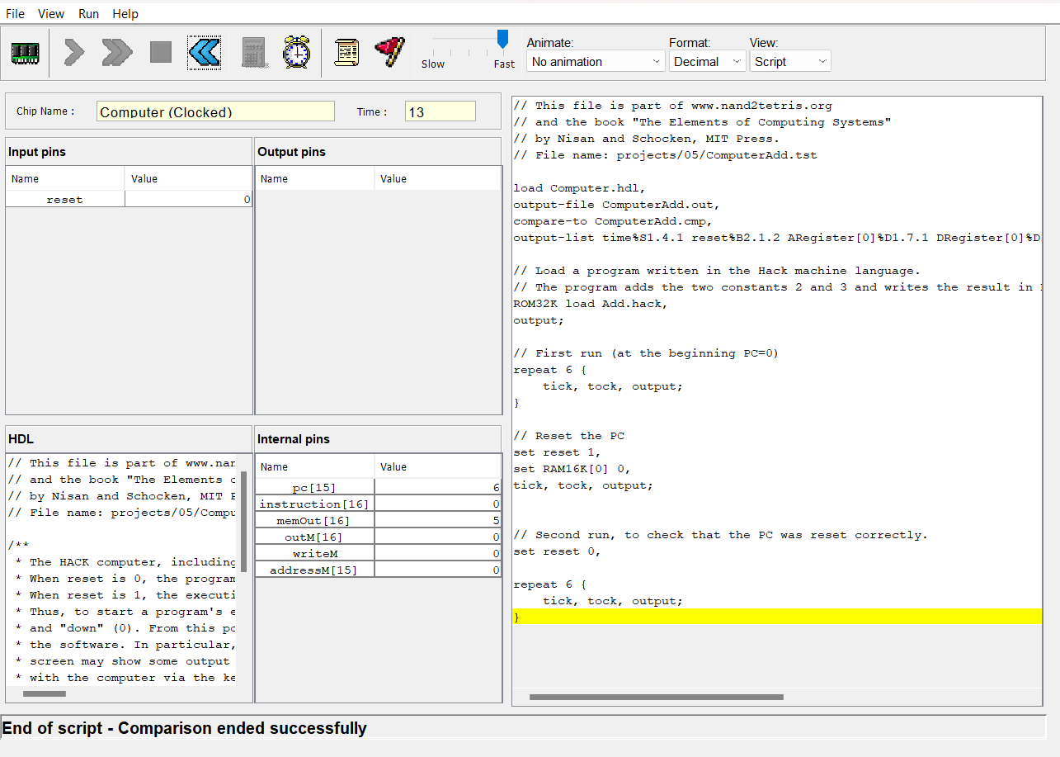
Figure 6 Computer Add output test
      - Test script:

// This file is part of www.nand2tetris.org
// and the book "The Elements of Computing Systems"
// by Nisan and Schocken, MIT Press.
// File name: projects/05/ComputerAdd.tst
load Computer.hdl,
output-file ComputerAdd.out,
compare-to ComputerAdd.cmp,
output-list time%S1.4.1 reset%B2.1.2 ARegister[0]%D1.7.1 DRegister[0]%D1.7.1 PC[]%D0.4.0 RAM16K[0]%D1.7.1 RAM16K[1]%D1.7.1 RAM16K[2]%D1.7.1;

// Load a program written in the Hack machine language.
// The program adds the two constants 2 and 3 and writes the result in RAM[0].
ROM32K load Add.hack,
output;

// First run (at the beginning PC=0)
repeat 6 {
tick, tock, output;
}

// Reset the PC
set reset 1,
set RAM16K[0] 0,
tick, tock, output;

// Second run, to check that the PC was reset correctly.
set reset 0,

repeat 6 {
tick, tock, output;
}

COMPUTER Add-external:
      - Output test:

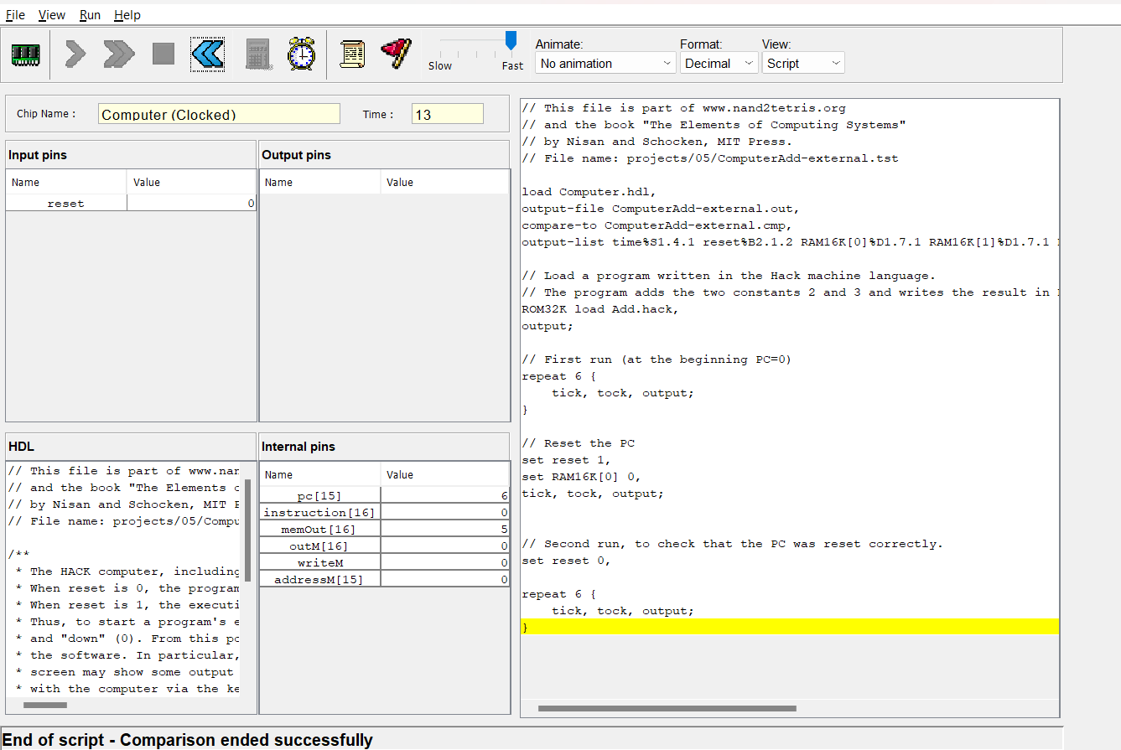
Figure 7 Computer Add-external output test

      - Test script:

// This file is part of www.nand2tetris.org
// and the book "The Elements of Computing Systems"
// by Nisan and Schocken, MIT Press.
// File name: projects/05/ComputerAdd-external.tst

load Computer.hdl,
output-file ComputerAdd-external.out,
compare-to ComputerAdd-external.cmp,
output-list time%S1.4.1 reset%B2.1.2 RAM16K[0]%D1.7.1 RAM16K[1]%D1.7.1 RAM16K[2]%D1.7.1;

// Load a program written in the Hack machine language.
// The program adds the two constants 2 and 3 and writes the result in RAM[0].
ROM32K load Add.hack,
output;

// First run (at the beginning PC=0)
repeat 6 {
tick, tock, output;
}

// Reset the PC
set reset 1,
set RAM16K[0] 0,
tick, tock, output;

// Second run, to check that the PC was reset correctly.
set reset 0,

repeat 6 {
tick, tock, output;
}

COMPUTER Max:
      - Output test:

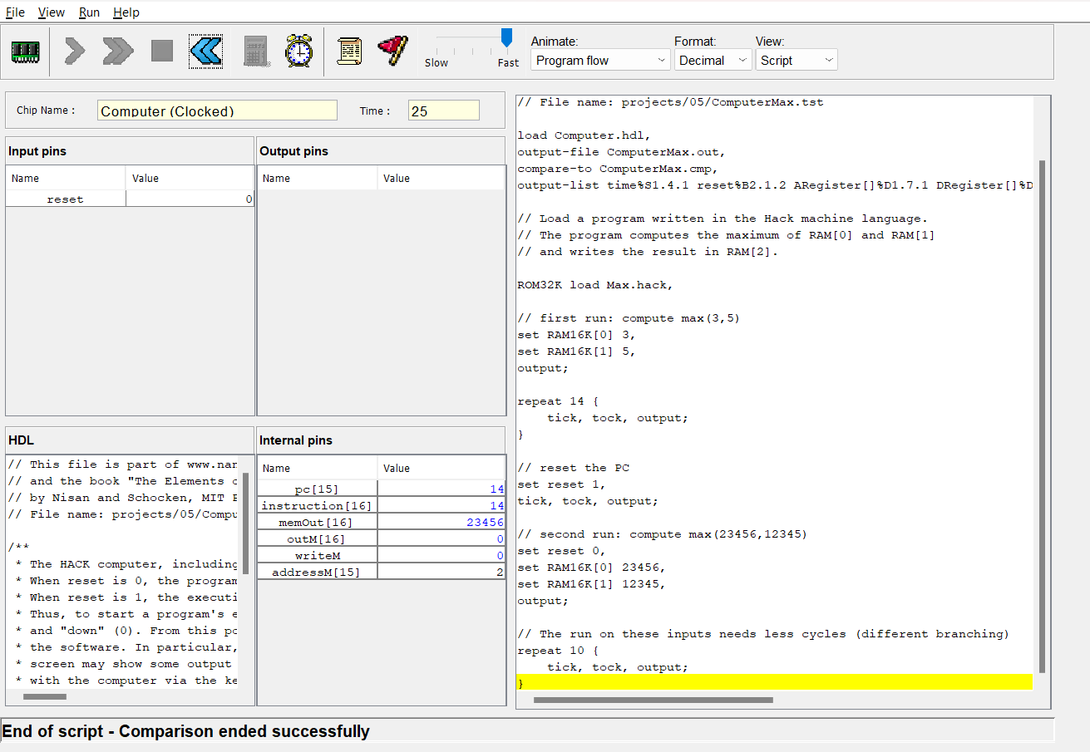
Figure 8 Computer Max output test
      - Test script:

// This file is part of www.nand2tetris.org
// and the book "The Elements of Computing Systems"
// by Nisan and Schocken, MIT Press.
// File name: projects/05/ComputerMax.tst

load Computer.hdl,
output-file ComputerMax.out,
compare-to ComputerMax.cmp,
output-list time%S1.4.1 reset%B2.1.2 ARegister[]%D1.7.1 DRegister[]%D1.7.1 PC[]%D0.4.0 RAM16K[0]%D1.7.1 RAM16K[1]%D1.7.1 RAM16K[2]%D1.7.1;

// Load a program written in the Hack machine language.
// The program computes the maximum of RAM[0] and RAM[1]
// and writes the result in RAM[2].
ROM32K load Max.hack,
// first run: compute max(3,5)
set RAM16K[0] 3,
set RAM16K[1] 5,
output;

repeat 14 {
tick, tock, output;
}

// reset the PC
set reset 1,
tick, tock, output;

// second run: compute max(23456,12345)
set reset 0,
set RAM16K[0] 23456,
set RAM16K[1] 12345,
output;

// The run on these inputs needs less cycles (different branching)
repeat 10 {
tick, tock, output;
}

COMPUTER Max-external:
      - Output test:

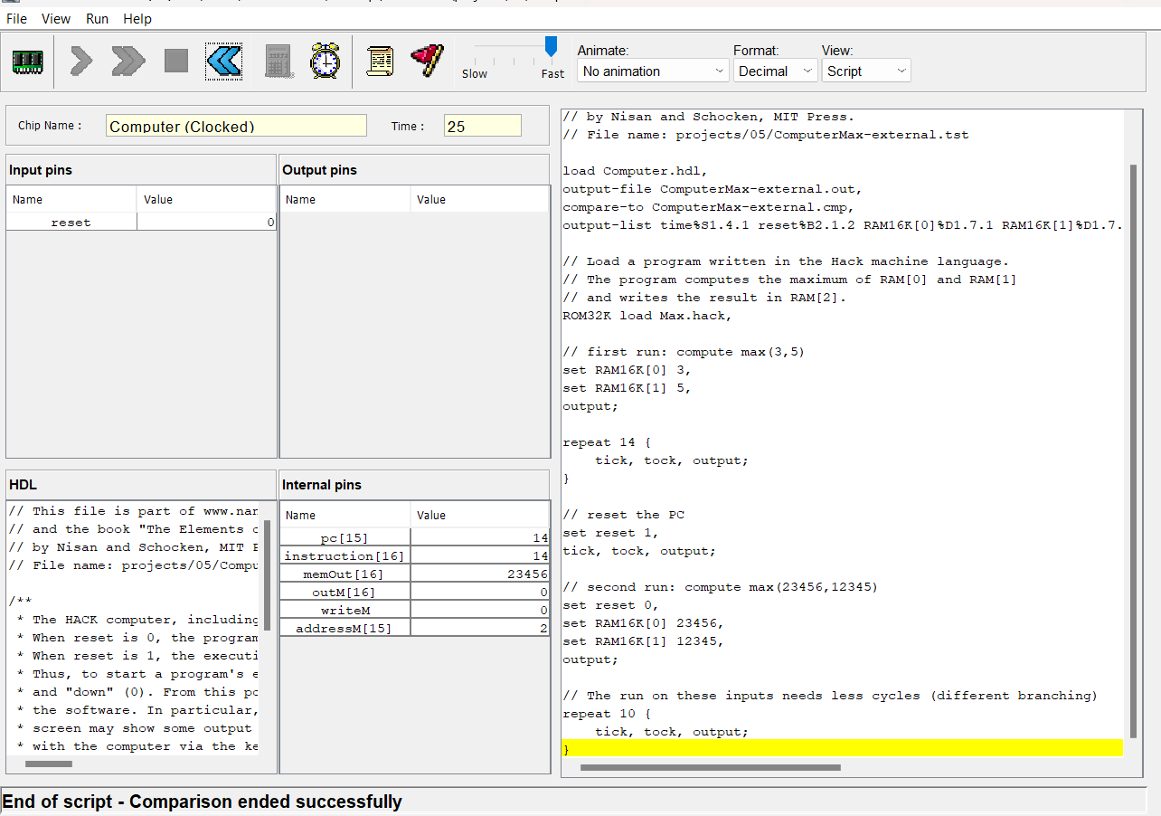
Figure 9 Computer Max-external output test
      - Test script:

// This file is part of www.nand2tetris.org
// and the book "The Elements of Computing Systems"
// by Nisan and Schocken, MIT Press.
// File name: projects/05/ComputerMax-external.tst

load Computer.hdl,
output-file ComputerMax-external.out,
compare-to ComputerMax-external.cmp,
output-list time%S1.4.1 reset%B2.1.2 RAM16K[0]%D1.7.1 RAM16K[1]%D1.7.1 RAM16K[2]%D1.7.1;

// Load a program written in the Hack machine language.
// The program computes the maximum of RAM[0] and RAM[1]
// and writes the result in RAM[2].
ROM32K load Max.hack,

// first run: compute max(3,5)
set RAM16K[0] 3,
set RAM16K[1] 5,
output;

repeat 14 {
tick, tock, output;
}

// reset the PC
set reset 1,
tick, tock, output;

// second run: compute max(23456,12345)
set reset 0,
set RAM16K[0] 23456,
set RAM16K[1] 12345,
output;

// The run on these inputs needs less cycles (different branching)
repeat 10 {
tick, tock, output;
}

COMPUTER Rect:
      - Output test:

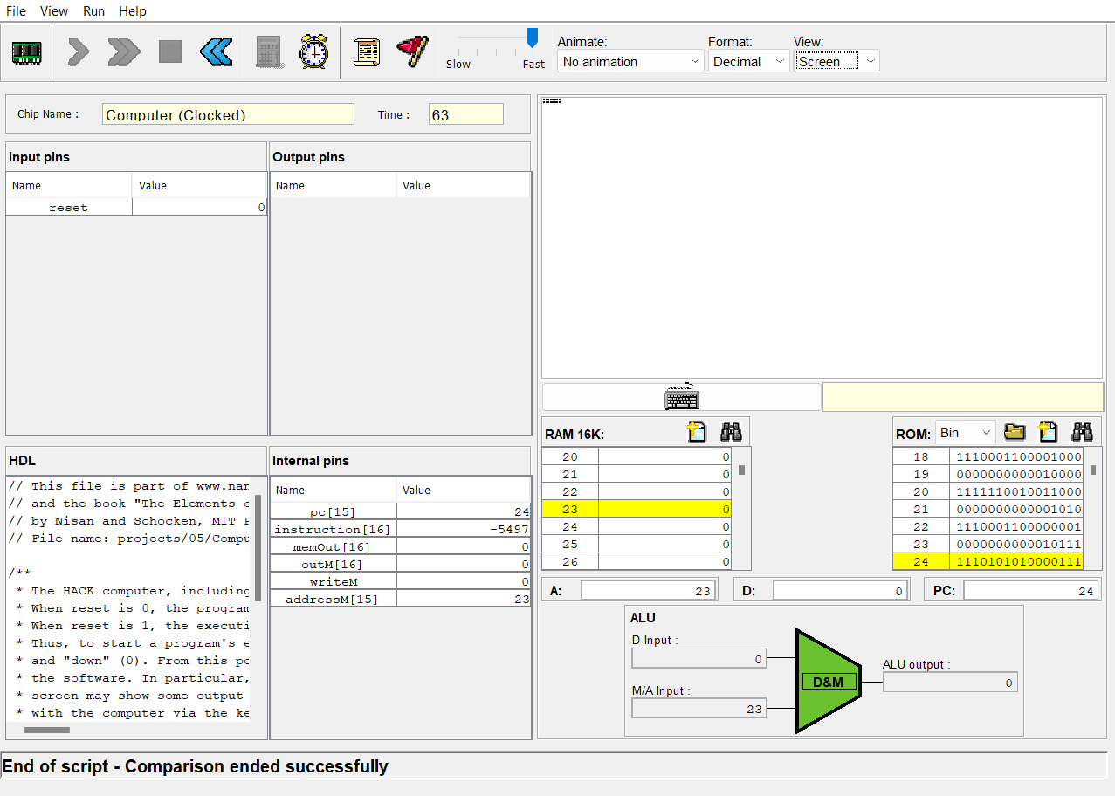
Figure 10 Computer Rect output test
      - Test script:

// This file is part of www.nand2tetris.org
// and the book "The Elements of Computing Systems"
// by Nisan and Schocken, MIT Press.
// File name: projects/05/ComputerRect.tst

load Computer.hdl,
output-file ComputerRect.out,
compare-to ComputerRect.cmp,
output-list time%S1.4.1 ARegister[]%D1.7.1 DRegister[]%D1.7.1 PC[]%D0.4.0 RAM16K[0]%D1.7.1 RAM16K[1]%D1.7.1 RAM16K[2]%D1.7.1;

// Load a program written in the Hack machine language.
// The program draws a rectangle of width 16 pixels and
// length RAM[0] at the top left of the screen.
ROM32K load Rect.hack,

echo "Before you run this script, select the 'Screen' option from the 'View' menu";

echo "A small rectangle should be drawn at the top left of the screen (the 'Screen' option of the 'View' menu should be selected.)";

// Draws a rectangle 16 pixels wide and 4 pixels long
set RAM16K[0] 4,
output;

repeat 63 {
tick, tock, output;
}

COMPUTER Rect-external:
      - Output test:

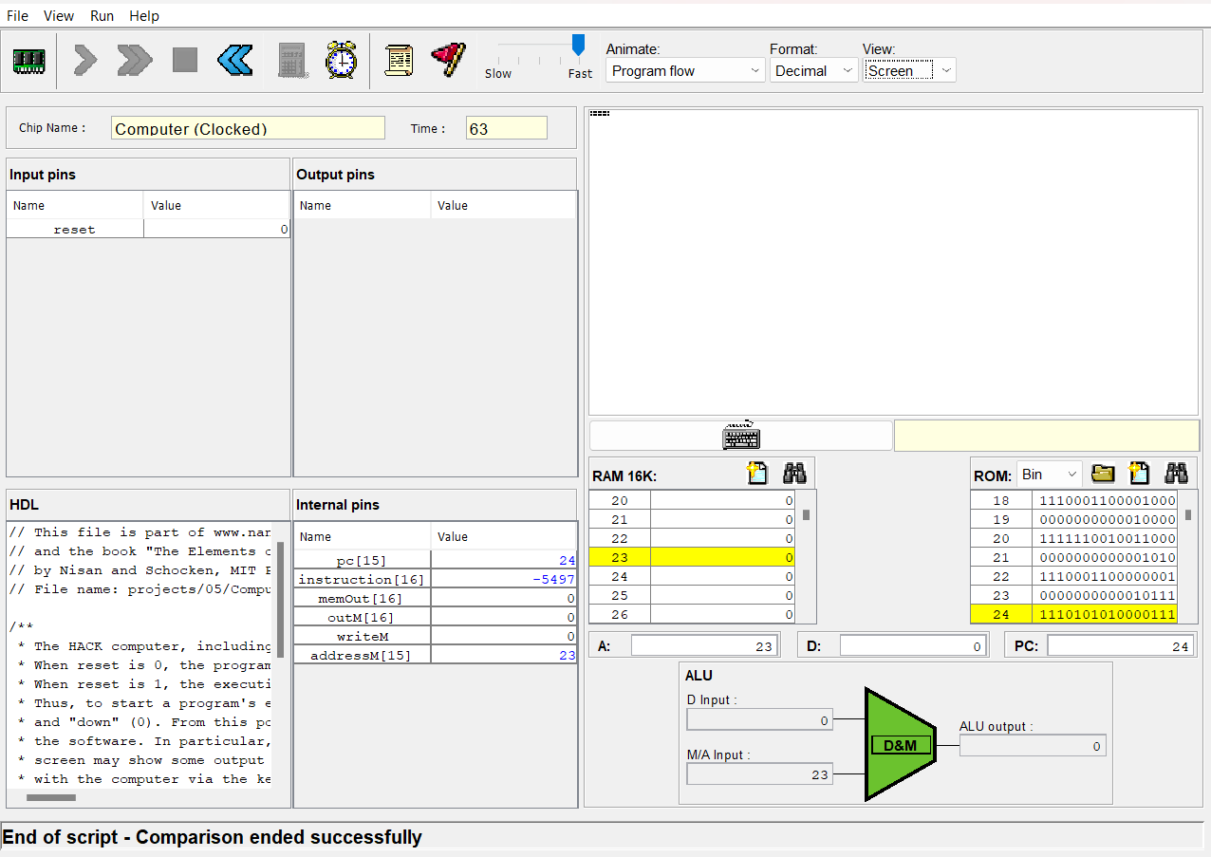
Figure 11 Computer Rect-external output test
      - Test script:
// This file is part of www.nand2tetris.org
// and the book "The Elements of Computing Systems"
// by Nisan and Schocken, MIT Press.
// File name: projects/05/ComputerRect-external.tst

load Computer.hdl,
output-file ComputerRect-external.out,
compare-to ComputerRect-external.cmp,
output-list time%S1.4.1;

// Load a program written in the Hack machine language.
// The program draws a rectangle of width 16 pixels and
// length RAM[0] at the top left of the screen.
ROM32K load Rect.hack,

echo "Before you run this script, select the 'Screen' option from the 'View' menu";

echo "A small rectangle should be drawn at the top left of the screen (the 'Screen' option of the 'View' menu should be selected.)";

// draw a rectangle 16 pixels wide and 4 pixels long
set RAM16K[0] 4,
output;

repeat 63 {
tick, tock, output;
}

COMPUTER Even-Odd (Newly created):
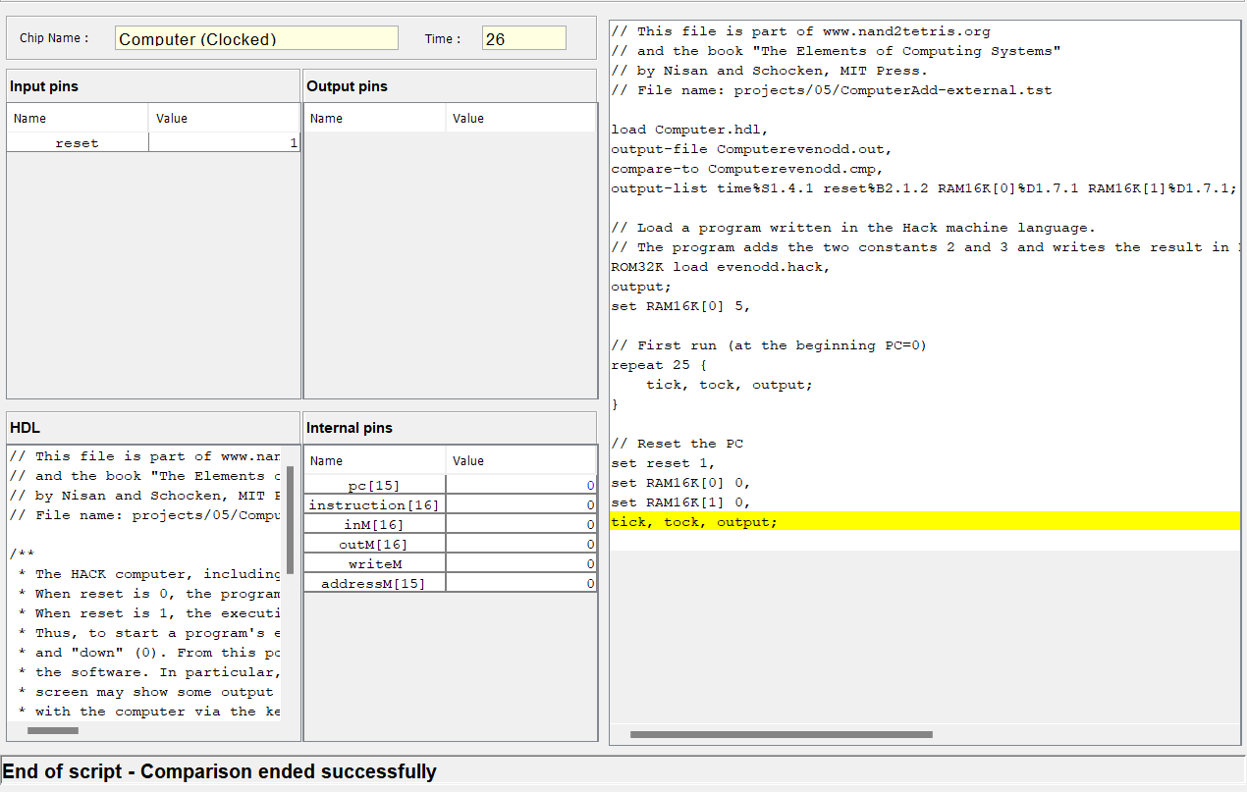
      - Output test:

Figure 12 Computer Even-odd output test

      - Test script:

// This file is part of www.nand2tetris.org
// and the book "The Elements of Computing Systems"
// by Nisan and Schocken, MIT Press.
// File name: projects/05/ComputerAdd-external.tst

load Computer.hdl,
output-file Computerevenodd.out,
compare-to Computerevenodd.cmp,
output-list time%S1.4.1 reset%B2.1.2 RAM16K[0]%D1.7.1 RAM16K[1]%D1.7.1;

// Load a program written in the Hack machine language.
// The program adds the two constants 2 and 3 and writes the result in RAM[0].
ROM32K load evenodd.hack,
output;
set RAM16K[0] 5,

// First run (at the beginning PC=0)
repeat 25 {
tick, tock, output;
}

// Reset the PC
set reset 1,
set RAM16K[0] 0,
set RAM16K[1] 0,
tick, tock, output;

CONCLUSION:

In conclusion, implementing the Hack computer in Hardware Description Language (HDL) can be a challenging yet rewarding endeavor. By translating the architecture and functionality of the Hack computer into HDL, you gain a deeper understanding of digital logic design and computer organization.

2. PART B

2.1 INTRODUCTION:

This report presents the implementation of a symbol table using the Jack programming language. A symbol table is a crucial data structure in programming language compilers and interpreters. It serves as a repository for storing and managing information about identifiers, such as variables, constants, and functions, used within a program.

The Jack programming language, designed specifically for educational purposes, provides a high-level abstraction for implementing various software components, including symbol tables. By constructing a symbol table in Jack, we can demonstrate its functionality in facilitating lexical analysis, semantic analysis, and code generation phases of a compiler.

This report discusses the design and implementation of the symbol table in Jack, outlining the data structures, algorithms, and operations utilized. The primary objectives include efficient storage and retrieval of symbol-related information, supporting scope management, type checking, and symbol resolution.

Furthermore, this report provides an overview of the Jack language features utilized to build the symbol table, such as classes, methods, variables, and control structures. Additionally, it explores the integration of the symbol table with the broader compiler infrastructure, showcasing how it interacts with other components to facilitate accurate program analysis and execution.

Overall, this report aims to demonstrate the practicality and effectiveness of utilizing the Jack programming language to implement a symbol table. It provides insights into the underlying concepts, design decisions, and programming techniques employed to develop a robust and functional symbol table, showcasing its significance in language processing tasks.

2.2 METHODOLOGY:

The basic ideology for coding in Jack to build SymbolTable is,
- Understanding Requirements: Analyze the symbol table needs, such as what information it should store and the operations it should support.
- Implement Symbol Table Operations: Write code in Jack to add symbols, search for symbols, update symbol attributes, and manage scopes.
- Test and Debug: Create test cases to verify the functionality of the symbol table and fix any issues that arise.

- Now let’s see how the coding for symbol table was implemented in JACK:

class Main {
static Array lineNumbers;
static Array reservedWords;
static Array variableNames;
static Array typeNames;
static Array procedureNames;
static Array stringNames;
static int count;
static int numOfValuesToEnter;
static int numOfValuesToView;

function int compareStrings(String str1, String str2) {
var int k;
let k = 0;
if (String.length(str1) = String.length(str2)) {
while (k < String.length(str1)) {
if (~(str1.charAt(k) = str2.charAt(k))) {
return 0;
}
let k = k + 1;
}
} else {
return 0;
}
return 1;
}

function void createArrays() {
let lineNumbers = Array.new(50);
let reservedWords = Array.new(50);
let variableNames = Array.new(50);
let typeNames = Array.new(50);
let procedureNames = Array.new(50);
let stringNames = Array.new(50);
return;
}

function void defineLineReservedVariable(String lineNumberArg, String reservedWordArg, String variableNameArg) {
let lineNumbers[count] = lineNumberArg;
let reservedWords[count] = reservedWordArg;
let variableNames[count] = variableNameArg;
return;
}

function void defineTypeProcedureString(String typeNameArg, String procedureNameArg, String stringNameArg) {
let typeNames[count] = typeNameArg;
let procedureNames[count] = procedureNameArg;
let stringNames[count] = stringNameArg;
let count = count + 1;
return;
}

function void showDataLineReserved(String lineNumberInput) {
var int x, y, comp, i;
var String reservedWordVal, variableNameVal;
let reservedWordVal = String.new(1000);
let variableNameVal = String.new(1000);
let i = count - 1;
while (i > -1) {
let x = lineNumberInput;
let y = lineNumbers[i];
let comp = Main.compareStrings(x, y);
if (comp = 1) {
let reservedWordVal = reservedWords[i];
let variableNameVal = variableNames[i];
do Output.printString("The data corresponding to the given line number is");
do Output.println();
do Output.println();
do Output.printString(reservedWordVal);
do Output.printString(" , ");
do Output.printString(variableNameVal);
}
let i = i - 1;
}
return;
}

function void showDataTypeProcedureString(String lineNumberInput) {
var int x, y, i, comp2;
var String typeNameVal, procedureNameVal, stringNameVal;
let typeNameVal = String.new(1000);
let procedureNameVal = String.new(1000);
let stringNameVal = String.new(1000);
let i = count - 1;
while (i > -1) {
let x = lineNumberInput;
let y = lineNumbers[i];
let comp2 = Main.compareStrings(x, y);
if (comp2 = 1) {
let typeNameVal = typeNames[i];
let procedureNameVal = procedureNames[i];
let stringNameVal = stringNames[i];
do Output.printString(" , ");
do Output.printString(typeNameVal);
do Output.printString(" , ");
do Output.printString(procedureNameVal);
do Output.printString(" , ");
do Output.printString(stringNameVal);
}
let i = i - 1;
}
return;
}

function void main() {
// Define entries in the symbol table
var String lineNumberVar, lineNumberInputForPrint;
var String reservedWordVar, variableNameVar, typeNameVar, procedureNameVar, stringNameVar;
do Main.createArrays();
let lineNumberInputForPrint = String.new(1000);
let count = 0;
let numOfValuesToEnter = 0;
let numOfValuesToView = 0;
let lineNumberVar = String.new(1000);
let reservedWordVar = String.new(1000);
let variableNameVar = String.new(1000);
let typeNameVar = String.new(1000);
let procedureNameVar = String.new(1000);
let stringNameVar = String.new(1000);
let numOfValuesToEnter = Keyboard.readInt("How many lines you want to enter in the Symbol Table: ");
do Output.println();
while (numOfValuesToEnter > 0) {
let lineNumberVar = Keyboard.readLine("Enter the line number of the tokenized line (in words): ");
do Output.println();
let reservedWordVar = Keyboard.readLine("Enter the Reserved word of that line: ");
do Output.println();
let variableNameVar = Keyboard.readLine("Enter the Variable Name of that line: ");
do Output.println();
let typeNameVar = Keyboard.readLine("Enter the Type Name of that line: ");
do Output.println();
let procedureNameVar = Keyboard.readLine("Enter the Procedure Name of that line: ");
do Output.println();
let stringNameVar = Keyboard.readLine("Enter the String Name present in that line: ");
do Output.println();
do Main.defineLineReservedVariable(lineNumberVar, reservedWordVar, variableNameVar);
do Main.defineTypeProcedureString(typeNameVar, procedureNameVar, stringNameVar);
let numOfValuesToEnter = numOfValuesToEnter - 1;
}
do Output.printString(" MAXIMUM LINES YOU CAN VIEW = ");
do Output.printInt(count);
do Output.println();
let numOfValuesToView = Keyboard.readInt("How many lines you want to view from the Symbol Table: ");
do Output.println();
while (numOfValuesToView > 0) {
let lineNumberInputForPrint = Keyboard.readLine("Enter the line number (in words): ");
do Output.println();
do Main.showDataLineReserved(lineNumberInputForPrint);
do Main.showDataTypeProcedureString(lineNumberInputForPrint);
let numOfValuesToView = numOfValuesToView - 1;
}
return; // Add a return statement
}
}

2.3 EXPERIMENTS & RESULTS:

The output of the Symbol Table generated by the VM emulator,
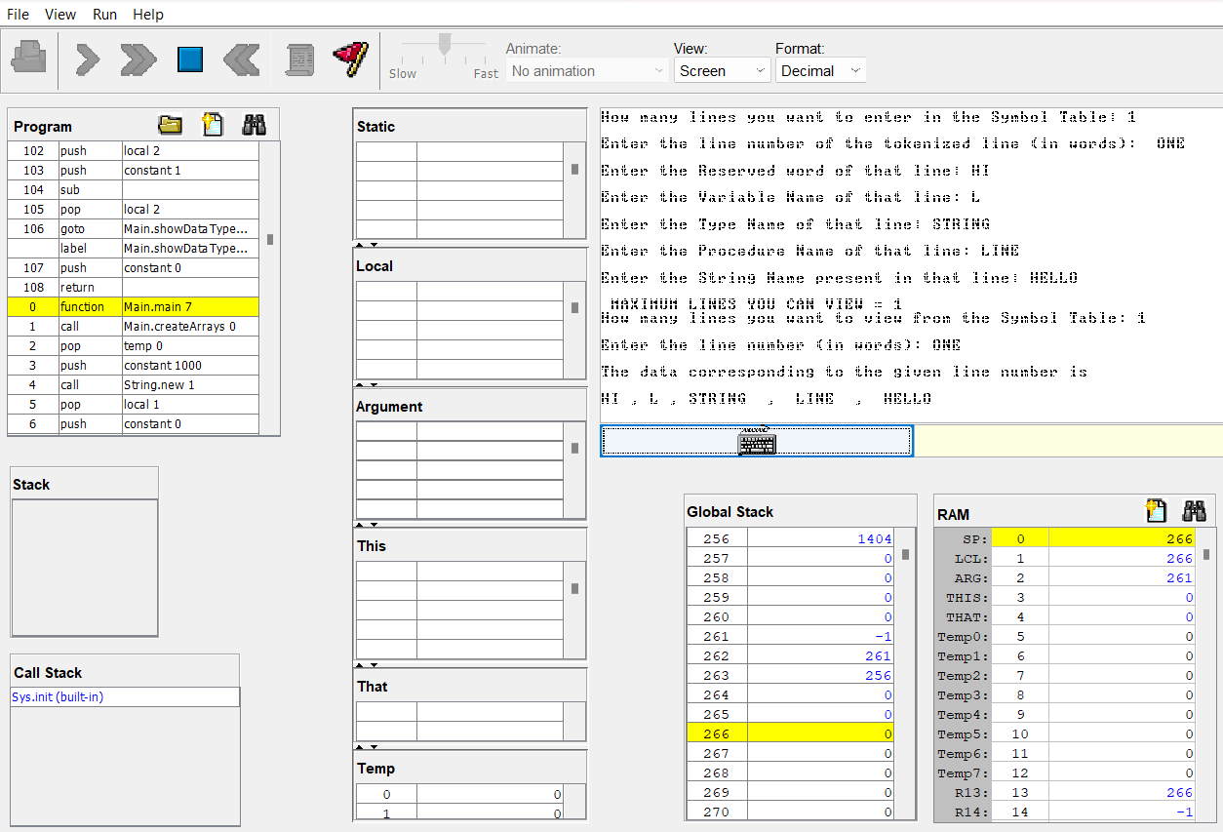
Figure 13 Symbol table output

2.4 CONCLUSION:

In conclusion, the implementation of a symbol table in the Jack language provides a crucial foundation for effective symbol management within programs. By coding and incorporating a symbol table, we have enabled accurate identification and tracking of symbols, such as variables, classes, and methods. The symbol table allows for efficient name resolution, preventing naming conflicts and ensuring correct symbol usage.With the symbol table in place, we have established a centralized repository for symbol information, facilitating quick symbol retrieval and enhancing overall performance during compilation or interpretation. Overall, our implementation of a symbol table in the Jack language empowers developers to build more robust and efficient programs.

3. PART C

MORSE CODE ENCRYPTION & DECRYPTION:

INTRODUCTION:

This report presents the development of a Jack program for encrypting and decrypting Morse code. Morse code, a widely-used communication system, represents letters and numbers using sequences of dots and dashes. The encryption process converts text into Morse code, while the decryption process reverses this conversion to retrieve the original text.

The Jack programming language, specifically designed for educational purposes, provides an ideal platform to implement this encryption and decryption functionality. By leveraging Jack's features such as string manipulation, control structures, and I/O operations, we can create a versatile program to handle Morse code encryption and decryption.

This report outlines the design and implementation of the Jack program, showcasing the algorithms and techniques utilized to convert text to Morse code and vice versa. The encryption process involves mapping each character to its corresponding Morse code representation, while the decryption process reverses this mapping to reconstruct the original text.

Furthermore, the report discusses the integration of the Morse code encryption and decryption functionalities into a user-friendly interface using the Jack language's I/O capabilities. This allows users to input text, encrypt it into Morse code, and decrypt Morse code back to the original text.

Overall, this report aims to demonstrate the practicality and effectiveness of utilizing the Jack programming language to develop a Morse code encryption and decryption program. It highlights the importance of Morse code as a communication system and showcases how the Jack language's features enable the creation of an efficient and user-friendly solution

METHODOLOGY:

      - ENCRYPTION:

Firstly, let’s start off with a basic idea of how to encrypt the morse code,
- Define a dictionary or lookup table that maps each letter, number, and punctuation mark to its corresponding Morse code representation. For example, 'A' corresponds to “.-”, 'B' corresponds to “-...”, and so on.
- Convert the input text to uppercase to ensure consistency.
- Iterate over each character in the text.
- Look up the Morse code representation for the current character from the dictionary.
- Append the Morse code representation to a result string, separating each Morse code sequence with a space or any other delimiter.
- Repeat this process for each character in the text until the entire text is encoded.
- The resulting string will be the encrypted Morse code representation of the input text.

Now with the prerequisite of knowing the idea behind it, we can get into how to code that in JACK language, since there is no inbuilt dictionary in the Jack language, I’ve used the if statements to assign the values respectively based on the characters. [3]

The Jack code for ENCRYPTION is given below:

class Main {
function void strconcat(String str1, String str2) {
var String result;
var int i, j;

let result = String.new(100);

let i = 0;
while (i < str1.length()) {
let result = result.appendChar(str1.charAt(i));
let i = i + 1;
}

let j = 0;
while (j < str2.length()) {
let result = result.appendChar(str2.charAt(j));
let j = j + 1;
}

do Output.printString(result);
return;
}

function String translate(String inputStr) {
var String output;
var String alphanum;
var int inputLength;
var int i;
var Char c;
var String morseCode;
let output = String.new(100);
let inputLength = String.length(inputStr);
let alphanum = String.new(100);
let alphanum = "ABCDEFGHIJKLMNOPQRSTUVWXYZ1234567890 ";
let morseCode = String.new(100);
let i = 0;

while (i < inputLength) {
let c = inputStr.charAt(i);

if (c = alphanum.charAt(0)) {
let morseCode = "*-";
}
if (c = alphanum.charAt(1)) {
let morseCode = "-***";
}
if (c = alphanum.charAt(2)) {
let morseCode = "-*-*";
}
if (c = alphanum.charAt(3)) {
let morseCode = "-**";
}
if (c = alphanum.charAt(4)) {
let morseCode = "*";
}
if (c = alphanum.charAt(5)) {
let morseCode = "**-*";
}
if (c = alphanum.charAt(6)) {
let morseCode = "--*";
}
if (c = alphanum.charAt(7)) {
let morseCode = "****";
}
if (c = alphanum.charAt(8)) {
let morseCode = "**";
}
if (c = alphanum.charAt(9)) {
let morseCode = "*---";
}
if (c = alphanum.charAt(10)) {
let morseCode = "-*-";
}
if (c = alphanum.charAt(11)) {
let morseCode = "*-**";
}
if (c = alphanum.charAt(12)) {
let morseCode = "--";
}
if (c = alphanum.charAt(13)) {
let morseCode = "-*";
}
if (c = alphanum.charAt(14)) {
let morseCode = "---";
}
if (c = alphanum.charAt(15)) {
let morseCode = "*--*";
}
if (c = alphanum.charAt(16)) {
let morseCode = "--*-";
}
if (c = alphanum.charAt(17)) {
let morseCode = "*-*";
}
if (c = alphanum.charAt(18)) {
let morseCode = "***";
}
if (c = alphanum.charAt(19)) {
let morseCode = "-";
}
if (c = alphanum.charAt(20)) {
let morseCode = "**-";
}
if (c = alphanum.charAt(21)) {
let morseCode = "***-";
}
if (c = alphanum.charAt(22)) {
let morseCode = "*--";
}
if (c = alphanum.charAt(23)) {
let morseCode = "-**-";
}
if (c = alphanum.charAt(24)) {
let morseCode = "-*--";
}
if (c = alphanum.charAt(25)) {
let morseCode = "--**";
}

if (c = alphanum.charAt(26)) {
let morseCode = "*----";
}
if (c = alphanum.charAt(27)) {
let morseCode = "**---";
}
if (c = alphanum.charAt(28)) {
let morseCode = "***--";
}
if (c = alphanum.charAt(29)) {
let morseCode = "****-";
}
if (c = alphanum.charAt(30)) {
let morseCode = "*****";
}
if (c = alphanum.charAt(31)) {
let morseCode = "-****";
}
if (c = alphanum.charAt(32)) {
let morseCode = "--***";
}
if (c = alphanum.charAt(33)) {
let morseCode = "---**";
}
if (c = alphanum.charAt(34)) {
let morseCode = "----*";
}
if (c = alphanum.charAt(35)) {
let morseCode = "-----";
}
if (c = alphanum.charAt(36)) {
let morseCode = "/";
}

if (String.length(morseCode) > 0) {
do Main.strconcat(output,morseCode);
}

let i = i + 1;
}
do Output.println();
do Output.printString(output);
return output;
}

function void main() {
var String inputStr;
var String outputStr;
let inputStr = Keyboard.readLine("Enter a word or sentence to translate: ");
let outputStr = String.new(100);
let outputStr = Main.translate(inputStr);

do Output.printString(outputStr);
do Output.println();

return;
}
}

Thus, the Encryption of Morse code can be programmed in this way using Jack language.
      - DECRYPTION:

Secondly now let’s see how to decrypt the Morse code, the basic idea behind decrypting a Morse code is,
- Split the Morse code input into individual sequences using the space or delimiter used during encryption.
- Iterate over each Morse code sequence.
- Look up the corresponding character for the Morse code sequence from the dictionary.
- Append the character to a result string.
- Repeat this process for each Morse code sequence until the entire Morse code input is decrypted.
- The resulting string will be the decrypted text.

The following chunks of code is DECRYPTION in JACK,
class Main {
function boolean compare(String str1,String str2){
var int i;
let i=0;
if(String.length(str1)=String.length(str2)){
while(i<String.length(str1)){
if(~(str1.charAt(i)=str2.charAt(i))){
return false;
}
let i=i+1;
}
}
else{
return false;
}
return true;
}

function String decodeCharacter(String morseCode) {
var Char decodedChar;

if (String.length(morseCode) = 0) {
return "";
}
let decodedChar = "";

if (Main.compare(morseCode,"*-")) {
let decodedChar = 65;
}
if (Main.compare(morseCode,"-***")) {
let decodedChar = 66;
}
if (Main.compare(morseCode,"-*-*")) {
let decodedChar = 67;
}
if (Main.compare(morseCode,"-**")) {
let decodedChar = 68;
}
if (Main.compare(morseCode,"*")) {
let decodedChar = 69;
}
if (Main.compare(morseCode,"**-*")) {
let decodedChar = 70;
}
if (Main.compare(morseCode,"--*")) {
let decodedChar = 71;
}
if (Main.compare(morseCode,"****")) {
let decodedChar = 72;
}
if (Main.compare(morseCode,"**")) {
let decodedChar = 73;
}
if (Main.compare(morseCode,"*---")) {
let decodedChar = 74;
}
if (Main.compare(morseCode,"-*-")) {
let decodedChar = 75;
}
if (Main.compare(morseCode,"*-**")) {
let decodedChar = 76;
}
if (Main.compare(morseCode,"*-**")) {
let decodedChar = 77;
}
if (Main.compare(morseCode,"-*")) {
let decodedChar = 78;
}
if (Main.compare(morseCode,"---")) {
let decodedChar = 79;
}
if (Main.compare(morseCode,"*--*")) {
let decodedChar = 80;
}
if (Main.compare(morseCode,"--*-")) {
let decodedChar = 81;
}
if (Main.compare(morseCode,"*-*")) {
let decodedChar = 82;
}
if (Main.compare(morseCode,"***")) {
let decodedChar = 83; }
if (Main.compare(morseCode,"-")) {
let decodedChar = 84;
}
if (Main.compare(morseCode,"**-")) {
let decodedChar = 85;
}
if (Main.compare(morseCode,"***-")) {
let decodedChar = 86;
}
if (Main.compare(morseCode,"*--")) {
let decodedChar = 87;
}
if (Main.compare(morseCode,"-**-")) {
let decodedChar = 88;
}
if (Main.compare(morseCode,"-*--")) {
let decodedChar = 89;
}
if (Main.compare(morseCode,"-*--")) {
let decodedChar = 90;
}

return decodedChar;
}

function String decodeWord(String morseCode) {
var int currentPosition;
var String decodedText, morseChar,c;
var Char decodedChar;
var Char curchar;

let currentPosition = 0;
let decodedText = String.new(100);
let morseChar = String.new(10000);
let c = ",";

while (currentPosition < String.length(morseCode)) {
let curchar = morseCode.charAt(currentPosition);

if (curchar = c.charAt(0)) {
if (String.length(morseChar) > 0) {

let decodedChar = Main.decodeCharacter(morseChar);
do Output.println();

do decodedText.appendChar(decodedChar);
let morseChar = String.new(100);
}

} else {
do morseChar.appendChar(curchar);

}

let currentPosition = currentPosition + 1;
}
if (String.length(morseChar) > 0){
let decodedChar = Main.decodeCharacter(morseChar);
do Output.println();

do decodedText.appendChar(decodedChar);
let morseChar = String.new(100);
}
return decodedText;
}
function void main() {
var String morseCode, decodedText;
let morseCode = Keyboard.readLine("Enter Morse code: ");
let decodedText = Main.decodeWord(morseCode);
if (String.length(decodedText) = 0) {
do Output.printString("Invalid Morse code");
} else {
do Output.printString(decodedText);
}
return;
}
}

Thus, Decryption of the Morse Code can be programmed in this manner using JACK language.

EXPERIMENTS & RESULTS:
      - Output for the Encryption:
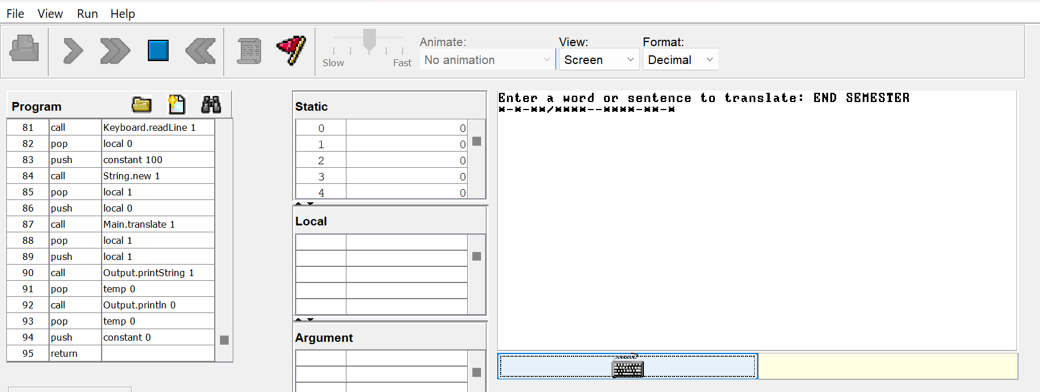
Figure 14 Morse code encryption output

      - Output for the Decryption:
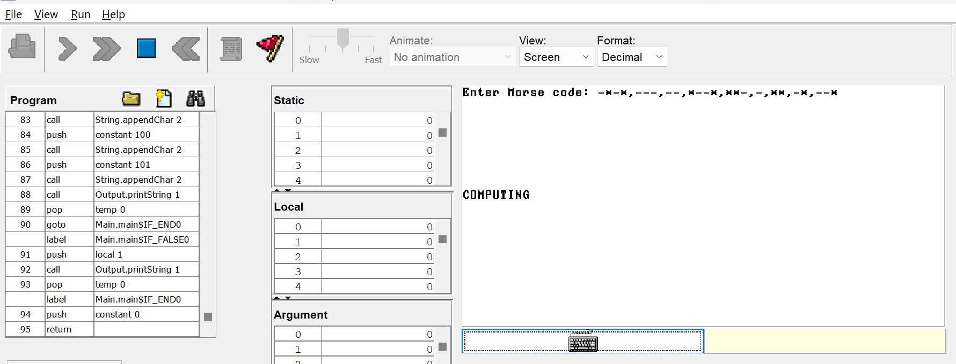
Figure 15 Morse code decryption output

ENCRYPTION & DECRYPTION USING CAESER CIPHER:

3.2.1 INTRODUCTION:

The objective of this part of the report is to present the implementation of encryption and decryption using the Caesar cipher algorithm in the Jack programming language. The Caesar cipher, also known as the shift cipher, is a widely recognized encryption technique that involves replacing each letter in the plaintext with a letter a fixed number of positions down the alphabet.

The Caesar cipher derives its name from Julius Caesar, who employed this technique to secure his military communications. It falls under the category of substitution ciphers, where each letter in the plaintext is substituted with another letter. In the case of the Caesar cipher, the substitution is based on a predetermined shift value.

This segment of the report will detail the development process of an encryption algorithm that applies the Caesar cipher to a given plaintext and a corresponding decryption algorithm to reverse the encryption process, restoring the original plaintext. Additionally, a user-friendly interface will be created to allow users to input the plaintext, specify the shift value, and view the encrypted and decrypted results.

Throughout the implementation, strict adherence to the syntax and rules of the Jack programming language will be maintained. By achieving these objectives, this project aims to showcase the practical application of the Caesar cipher algorithm in the Jack language, particularly in the context of data encryption and decryption.

[1] [2] [3]

3.2.2 METHODOLOGY:

In the Caesar cipher algorithm, encryption and decryption are relatively straightforward processes. The key concept behind this cipher is shifting the letters of the alphabet by a fixed number of positions to encrypt the plaintext and then shifting them back by the same number of positions to decrypt the ciphertext.
      - ENCRYPTION:

- Start with a given plaintext message and a shift value (a positive integer).
- Iterate over each letter in plaintext.
- Determine the position of the current letter in the alphabet.
- Shift the letter by the specified number of positions (according to the shift value).
- Wrap around the alphabet if the shifting goes beyond the boundaries (e.g., shifting 'z' by 1 results in 'a').
- Replace the current letter in the plaintext with the shifted letter to generate the ciphertext.
- Repeat steps 3-6 for all letters in the plaintext to obtain the complete encrypted message (ciphertext).

Now that we have an idea of how the Caesar cipher algorithm works we will see its implementation in Jack language:

class Main {
function int mod(int a, int b) {
while (a > b) {
let a = a - b;
}
return a;
}

function void main() {
var String plaintext;
var String ciphertext;
var int shift;
var int currentChar;
var char encryptedChar;
var int i;

let shift = 3;
let plaintext=Keyboard.readLine("Enter a string to encrypt: ");
let i = 0;
let ciphertext=String.new(100);
while (i < String.length(plaintext)){
let currentChar = plaintext.charAt(i);
let encryptedChar = Main.mod((currentChar - 65 + shift), 26) + 65;
do ciphertext.appendChar(encryptedChar);
let i = i + 1;
}

do Output.printString("Encrypted message: ");
do Output.printString(ciphertext);
return;
}
}

This code takes the input string, shifts each character by the specified amount (Here we have taken the shift amount as 3), and generates the encrypted message, which is then printed as the output.
      - DECRYPTION:
- Start with a given ciphertext message and the same shift value used for encryption.
- Iterate over each letter in the ciphertext.
- Determine the position of the current letter in the alphabet.
- Shift the letter backward by the specified number of positions (according to the shift value).
- Wrap around the alphabet if necessary.
- Replace the current letter in the ciphertext with the shifted letter to retrieve the original plaintext.
- Repeat steps 3-6 for all letters in the ciphertext to obtain the complete decrypted message (plaintext)
The following chunks of code is for decryption in JACK:

class Main {
function int mod(int a, int b) {
while (a > 0) {
let a = a - b;
}
return a;
}

function char decode(String inputstr,int shift) {
var int ascii,i,inputlength;
var Char decodedAscii;
var String output;
var String decodedword;
var String alphanum;
var Char c;
let alphanum = String.new(100);
let decodedword = String.new(100);
let output = String.new(100);
let alphanum = "ABCDEFGHIJKLMNOPQRSTUVWXYZ1234567890";
let i =0;
let inputlength = String.length(inputstr);

while(i<inputlength){
let c = inputstr.charAt(i);
do Output.printChar(c);

if (c = alphanum.charAt(0)) {
let ascii = c;
let decodedAscii = Main.mod((ascii - shift - alphanum.charAt(0) + 26), 26) + alphanum.charAt(0);
let decodedword = decodedword.appendChar(decodedAscii);
}

if (c = alphanum.charAt(1)) {
let ascii = c;
let decodedAscii = Main.mod((ascii - shift - alphanum.charAt(1) + 26), 26) + alphanum.charAt(1);
let decodedword = decodedword.appendChar(decodedAscii);
}

if (c = alphanum.charAt(2)) {
let ascii = c;
let decodedAscii = Main.mod((ascii - shift - alphanum.charAt(2) + 26), 26) + alphanum.charAt(2);
let decodedword = decodedword.appendChar(decodedAscii);
}

if (c = alphanum.charAt(3)) {
let ascii = c;
let decodedAscii = Main.mod((ascii - shift - alphanum.charAt(3) + 26), 26) + alphanum.charAt(3);
let decodedword = decodedword.appendChar(decodedAscii);
}

if (c = alphanum.charAt(4)) {
let ascii = c;
let decodedAscii = Main.mod((ascii - shift - alphanum.charAt(4) + 26), 26) + alphanum.charAt(4);
let decodedword = decodedword.appendChar(decodedAscii);
}

if (c = alphanum.charAt(5)) {
let ascii = c;
let decodedAscii = Main.mod((ascii - shift - alphanum.charAt(5) + 26), 26) + alphanum.charAt(5);
let decodedword = decodedword.appendChar(decodedAscii);
}

if (c = alphanum.charAt(6)) {
let ascii = c;
let decodedAscii = Main.mod((ascii - shift - alphanum.charAt(6) + 26), 26) + alphanum.charAt(6);
let decodedword = decodedword.appendChar(decodedAscii);
}

if (c = alphanum.charAt(7)) {
let ascii = c;
let decodedAscii = Main.mod((ascii - shift - alphanum.charAt(7) + 26), 26) + alphanum.charAt(7);
let decodedword = decodedword.appendChar(decodedAscii);
}

if (c = alphanum.charAt(8)) {
let ascii = c;
let decodedAscii = Main.mod((ascii - shift - alphanum.charAt(8) + 26), 26) + alphanum.charAt(8);
let decodedword = decodedword.appendChar(decodedAscii);
}

if (c = alphanum.charAt(9)) {
let ascii = c;
let decodedAscii = Main.mod((ascii - shift - alphanum.charAt(9) + 26), 26) + alphanum.charAt(9);
let decodedword = decodedword.appendChar(decodedAscii);
}

if (c = alphanum.charAt(10)) {
let ascii = c;
let decodedAscii = Main.mod((ascii - shift - alphanum.charAt(10) + 26), 26) + alphanum.charAt(10);
let decodedword = decodedword.appendChar(decodedAscii);
}

if (c = alphanum.charAt(11)) {
let ascii = c;
let decodedAscii = Main.mod((ascii - shift - alphanum.charAt(11) + 26), 26) + alphanum.charAt(11);
let decodedword = decodedword.appendChar(decodedAscii);
}

if (c = alphanum.charAt(12)) {
let ascii = c;
let decodedAscii = Main.mod((ascii - shift - alphanum.charAt(12) + 26), 26) + alphanum.charAt(12);
let decodedword = decodedword.appendChar(decodedAscii);
}

if (c = alphanum.charAt(13)) {
let ascii = c;
let decodedAscii = Main.mod((ascii - shift - alphanum.charAt(13) + 26), 26) + alphanum.charAt(13);
let decodedword = decodedword.appendChar(decodedAscii);
}

if (c = alphanum.charAt(14)) {
let ascii = c;
let decodedAscii = Main.mod((ascii - shift - alphanum.charAt(14) + 26), 26) + alphanum.charAt(14);
let decodedword = decodedword.appendChar(decodedAscii);
}

if (c = alphanum.charAt(15)) {
let ascii = c;
let decodedAscii = Main.mod((ascii - shift - alphanum.charAt(15) + 26), 26) + alphanum.charAt(15);
let decodedword = decodedword.appendChar(decodedAscii);
}

if (c = alphanum.charAt(16)) {
let ascii = c;
let decodedAscii = Main.mod((ascii - shift - alphanum.charAt(16) + 26), 26) + alphanum.charAt(16);
let decodedword = decodedword.appendChar(decodedAscii);
}

if (c = alphanum.charAt(17)) {
let ascii = c;
let decodedAscii = Main.mod((ascii - shift - alphanum.charAt(17) + 26), 26) + alphanum.charAt(17);
let decodedword = decodedword.appendChar(decodedAscii);
}

if (c = alphanum.charAt(18)) {
let ascii = c;
let decodedAscii = Main.mod((ascii - shift - alphanum.charAt(18) + 26), 26) + alphanum.charAt(18);
let decodedword = decodedword.appendChar(decodedAscii);
}

if (c = alphanum.charAt(19)) {
let ascii = c;
let decodedAscii = Main.mod((ascii - shift - alphanum.charAt(19) + 26), 26) + alphanum.charAt(19);
let decodedword = decodedword.appendChar(decodedAscii);
}

if (c = alphanum.charAt(20)) {
let ascii = c;
let decodedAscii = Main.mod((ascii - shift - alphanum.charAt(20) + 26), 26) + alphanum.charAt(20);
let decodedword = decodedword.appendChar(decodedAscii);
}

if (c = alphanum.charAt(21)) {
let ascii = c;
let decodedAscii = Main.mod((ascii - shift - alphanum.charAt(21) + 26), 26) + alphanum.charAt(21);
let decodedword = decodedword.appendChar(decodedAscii);
}

if (c = alphanum.charAt(22)) {
let ascii = c;
let decodedAscii = Main.mod((ascii - shift - alphanum.charAt(22) + 26), 26) + alphanum.charAt(22);
let decodedword = decodedword.appendChar(decodedAscii);
}

if (c = alphanum.charAt(23)) {
let ascii = c;
let decodedAscii = Main.mod((ascii - shift - alphanum.charAt(23) + 26), 26) + alphanum.charAt(23);
let decodedword = decodedword.appendChar(decodedAscii);
}

if (c = alphanum.charAt(24)) {
let ascii = c;
let decodedAscii = Main.mod((ascii - shift - alphanum.charAt(24) + 26), 26) + alphanum.charAt(24);
let decodedword = decodedword.appendChar(decodedAscii);
}

if (c = alphanum.charAt(25)) {
let ascii = c;
let decodedAscii = Main.mod((ascii - shift - alphanum.charAt(25) + 26), 26) + alphanum.charAt(25);
let decodedword = decodedword.appendChar(decodedAscii);
}

if (String.length(decodedword)>0) {
do output.appendChar(decodedAscii);
}

let i=i+1;
}
do Output.println();
return output;
}

function void main() {
var int shift;
var String inputstr;
var String outputstr;
let shift = 3;
let inputstr = Keyboard.readLine("Enter a word to translate: ");
let outputstr = String.new(100);
let outputstr = Main.decode(inputstr,shift);

do Output.printString(outputstr);
do Output.println();

return;
}
}

This code takes an encoded string and a shift value(Here the shift value is taken as 3) decodes each character based on the Caesar cipher algorithm and returns the decoded message as output.
- Therefore, Encryption & Decryption using Caesar cipher algorithm can be programmed in this manner using JACK language.

EXPERIMENTS & RESULTS:
      - Output for the Encryption Code:

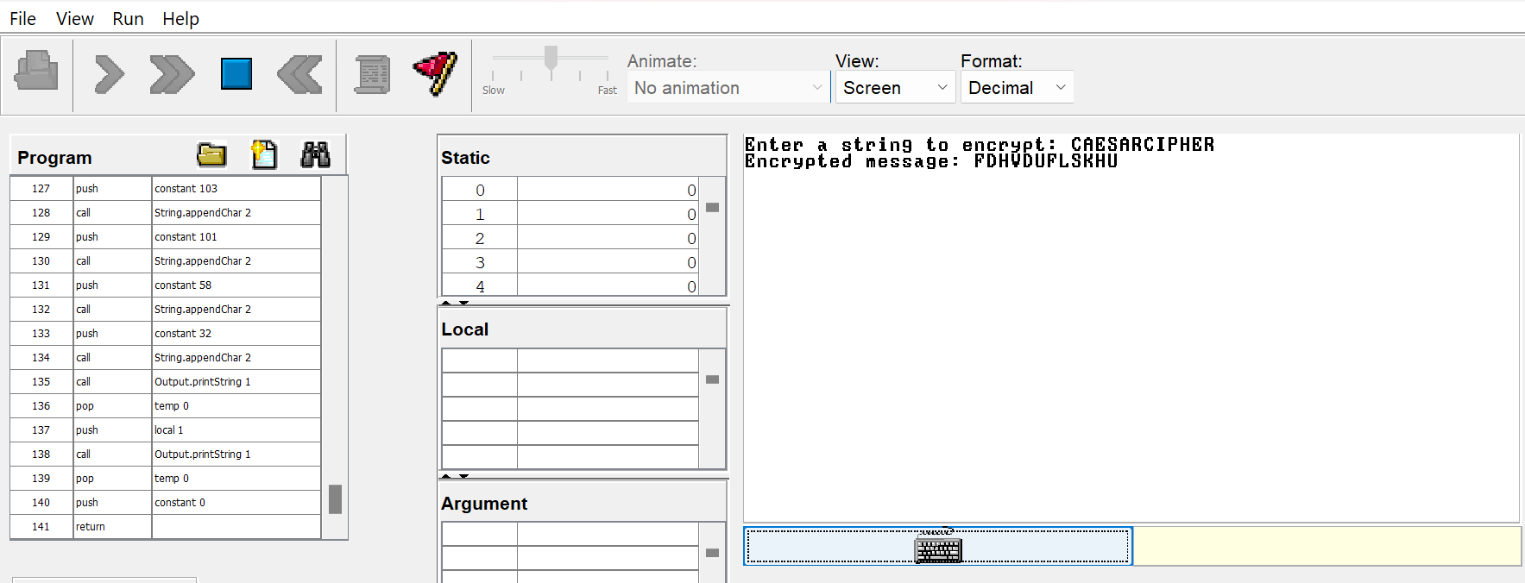
Figure 16 Caeser cipher encryption output
      - Output for the Decryption Code:

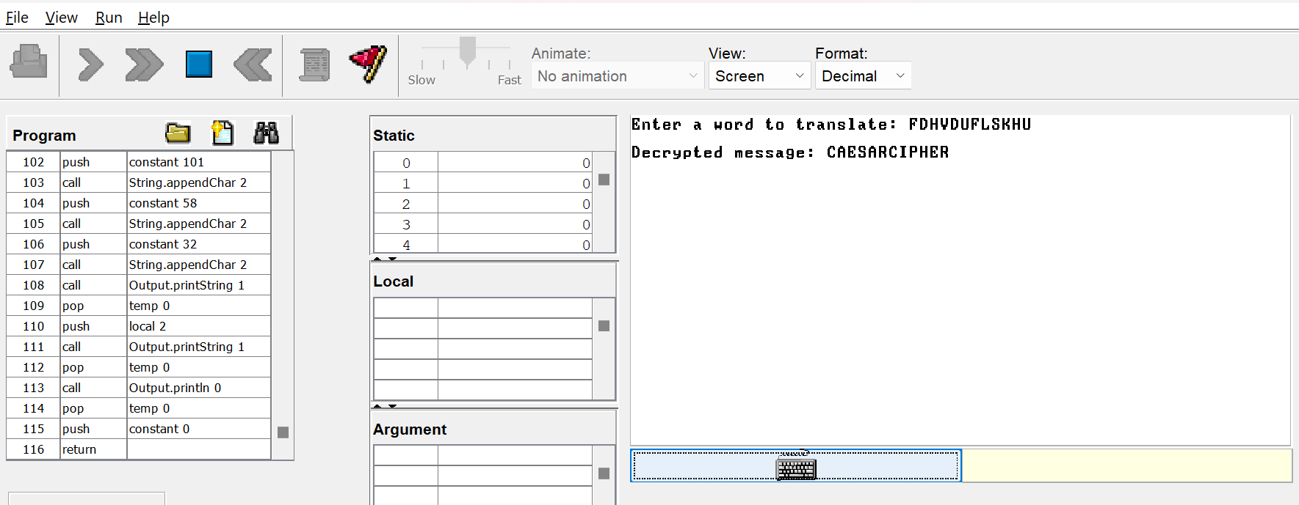

Figure 17 Caeser cipher decryption output

3.3 CONCLUSION:

In conclusion, this report focused on implementing encryption and decryption algorithms for Morse code and Caesar cipher in the JACK language.

The Morse code encryption and decryption algorithms were successfully implemented using JACK. The encryption process involved converting plain text into its corresponding Morse code representation, using dots and dashes to represent each character. The decryption process reversed this conversion, translating Morse code sequences back into readable text. The implemented algorithms allow for the secure transmission and reception of messages using the Morse code encoding scheme.

Similarly, the Caesar cipher encryption and decryption algorithms were successfully implemented in the JACK language. The encryption algorithm involved shifting each letter in the plain text by a fixed number of positions, while the decryption algorithm reversed this process to retrieve the original message. The implemented algorithms provide a basic but effective method of protecting sensitive information by altering the positions of characters in the alphabet.

By implementing these encryption and decryption algorithms in the JACK language, a better understanding of the concepts and techniques used in cryptography was gained. It highlighted the importance of data confidentiality and the need for robust encryption methods. Both Morse code and Caesar cipher served as foundational examples of encryption techniques, demonstrating different approaches to securing information.

REFERENCES

[1] | "wikipedia," [Online]. Available: https://en.wikipedia.o35rg/wiki/Hack_computer#:~:text=As%20illustrated%20in%20the%20accompanying,in%20simple%2C%20commercially%20available%20CPUs..
[2] | "elements of computing," [Online]. Available: file:///D:/Documents/SEMESTER%202/EOC%202/Books/The%20Elements%20of%20Computing%20Systems.pdf.
[3] | "geek for geeks," [Online]. Available: https://www.geeksforgeeks.org/symbol-table-compiler/.

